# [**The FBI and FBI: Most Wanted Teams Answer Reader Questions, Tease a 'Ticking Clock,' Roommates and More**](https://tvline.com/2020/11/17/fbi-season-3-preview-fbi-most-wanted-season-2-spoile)

By [Vlada Gelman](https://tvline.com/author/vlada-gelman/) and [Matt Webb Mitovich](https://tvline.com/author/matt-webb-mitovich/) / November 17 2020, 6:26 AM PST

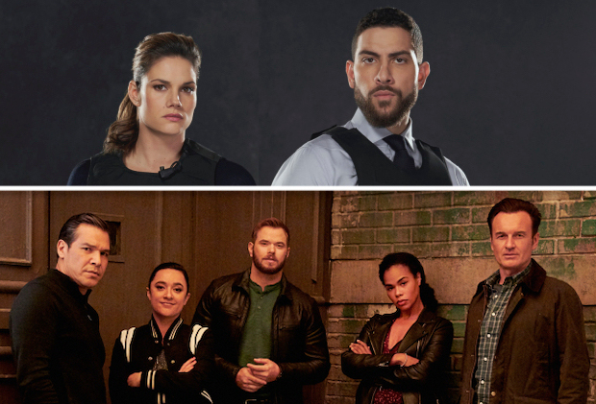

Courtesy of CBS

* [**5**](https://tvline.com/2020/11/17/fbi-season-3-preview-fbi-most-wanted-season-2-spoilers/#comments)

With both [*FBI*](http://tvline.com/tag/fbi) and [*FBI: Most Wanted*](http://tvline.com/tag/fbi-most-wanted) returning for new seasons this Tuesday night, TVLine sought out answers to many reader questions about the CBS procedurals.

In the mothership’s Season 3 premiere (airing tonight at 9/8c), the team welcomes a new member, Special Agent Tiffany Wallace (played by Katherine Renee Turner), as they search for killers who orchestrated a mass shooting at a media company, while OA’s personal connection with the case threatens to cloud his judgement.

Then at 10 pm, in *FBI: Most Wanted*‘s sophomore opener, with COVID devastating the country, two gunmen take out their desperation and rage on the elite class they perceive to be oppressing them. Also, Jess’ father (*Lost*‘s Terry O’Quinn) returns to his son’s life.

**But wait, there is so much more to be known about the seasons ahead!** Read on for *FBI* intel, then [click over to Page 2 to get the scoop on *Most Wanted*](https://tvline.com/2020/11/17/fbi-season-3-preview-fbi-most-wanted-season-2-spoilers/2/).

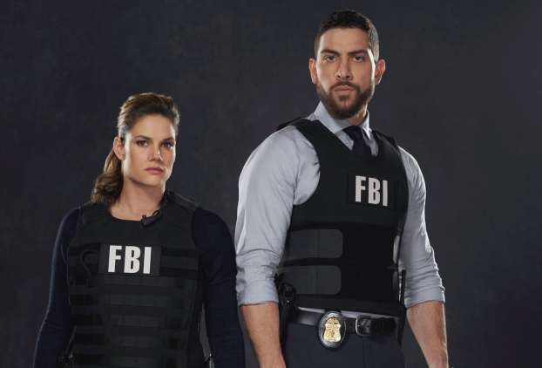**How far into the new season will we learn more about Maggie’s undercover mission? –Chloe**  
**RICK EID, Executive Producer |** Maggie returns very much ready to start a new chapter. She’s not eager to share much about her time undercover, not even with OA. But some details will be revealed in this week’s premiere.

**Will things be any different between OA and Maggie because of her prolonged absence? –Tala**  
**EID |** When Maggie returns to 26 Fed, she’s ready to hit the ground running. As partners, OA and Maggie are a click “off” at first, but eventually fall back into a comfortable rhythm as time progresses. OA also senses that Maggie is hiding something from him, making things even more complicated.

**What episode are you most excited for fans to see? –Katie**  
**EID |** All of them. But if I had to pick one… I’d say Episode 3 is especially exciting. Let’s just say it involves a ticking clock… inside 26 Fed.

**Are we going to get another crossover with *FBI: Most Wanted*? –David**  
**EID |** We are hoping to do a crossover with *FBI: Most Wanted*, but the production constraints with COVID protocols pose an extra challenge. Viewers will see glimpses of characters from both shows interacting with one another, but it is doubtful we will be able to do a “real” crossover. But you should expect to see Isobel (played by Alana De La Garza) pop up on *FBI: Most Wanted* from time to time.

**What was the hardest scene to film so far in this upcoming season? –Cleekers**  
**JEREMY SISTO, who plays Special Agent Jubal Valentine |** The hardest scene for me to film so far this season was a scene I had to do with Jubal’s ex-partner (*Patriot*‘s Kathleen Munroe) for the second episode. In the scene, we reconnect because Jubal is questioning a case that they worked back when they were partners, when Jubal was still in the throes of alcohol addiction and his marriage was collapsing. It was not something that she wants to hear, so it was a complex scene with a lot of emotions and competing objectives.  
ZEEKO ZAKI, who plays Special Agent ‘OA’ Zidan **|** The most difficult scene for me to film in the premiere episode was the hostage negotiation moment because there have been so many legendary performances of that scenario in movies and television since the beginning of entertainment. There was a responsibility to do it differently and get it right; Finding that was exciting and challenging.

**NOW** [**CLICK TO PAGE 2 FOR *FBI: MOST WANTED* INTEL**](https://tvline.com/2020/11/17/fbi-season-3-preview-fbi-most-wanted-season-2-spoilers/2/)**!**

***If you like TVLine, you'll LOVE our weekly newsletter.*** [***Click here to subscribe.***](https://pages.email.tvline.com/signup/)

# **The *FBI* and *FBI: Most Wanted* Teams Answer Reader Questions, Tease a 'Ticking Clock,' Roommates and More**

By [Vlada Gelman](https://tvline.com/author/vlada-gelman/) and [Matt Webb Mitovich](https://tvline.com/author/matt-webb-mitovich/) / November 17 2020, 6:26 AM PST



Courtesy of CBS

* [**5**](https://tvline.com/2020/11/17/fbi-season-3-preview-fbi-most-wanted-season-2-spoilers/#comments)

***FBI: MOST WANTED*: TVLINE READER QUESTIONS ANSWERED!**

**Season 1 brought us some Hana (Keisha Castle-Hughes) and Crosby (Kellan Lutz) vibes. Will Season 2 do the same? –Stephanie**  
**DAVID HUDGINS, Executive Producer |** I love the relationship between these two younger members of the team and we are digging into that. Hana and Crosby become temporary roommates at one point, and we’ll see a bond develop outside of work that gives us a window into what it’s like to be an FBI agent while also “adulting” in New York City during a pandemic. Keisha and Kellan are great together onscreen.

**What episode are you most excited for fans to see? –Katie**  
**HUDGINS |** We have a pair of episodes where we meet the families of both Hana and Crosby, and also complicate their roommate relationship. It’s fun and topical, and I think very entertaining to see them not only have conflict, but also be there for each other.

**We’ve seen the bond Tali (YaYa Gosselin) has with her grandparents and Jess (Julian McMahon), but will we get to see more of her dynamic with her Uncle Clinton (Nathaniel Arcand)? –Beth**  
**HUDGINS |** Yes. There is a theme of family that is emerging in Season 2 and Tali’s relationship with her uncle is a part of that.

**Will the writers be giving Julian McMahon’s Jess LaCroix a love interest down the road, or do they plan to keep him a widower? –Linda**  
**HUDGINS |** In the writers’ room, we were all interested in exploring the idea of when Jess will be ready for love again. He’ll meet a teacher at Tali’s new school — who also lost her spouse — and as the relationship develops, it gets complicated because of Tali’s growing expectations.

**What was the hardest scene to film so far this season? –Cleekers**  
**KELLAN LUTZ, who plays Special Agent Kenny Crosby |** I think that something like 93 percent of our communication as human beings is nonverbal, so the scenes where we have to wear masks are especially challenging; character-wise, it’s much harder to tell if the person Cosby is interviewing is telling the truth or not. Much like sending a joke or being sarcastic via text message, it’s a lot harder to figure out without tone or context. It takes so much of the humanity out of the storytelling we’re trying to do, so that’s definitely been an adjustment. But of course, everyone’s safety is our primary concern so it’s not a complaint, just a challenge! I’m looking forward to the day where this pandemic is behind us and we can be free to interact and hug each other and spend time together again in the community and in scenes.

***Want scoop on any of the above shows? Email*** [***InsideLine@tvline.com***](http://insideline@tvline.xn--com-9o0a/) ***and your question may be answered via*** [***Matt’s Inside Line***](http://tvline.com/category/matts-inside-line/)***.***

***If you like TVLine, you'll LOVE our weekly newsletter.*** [***Click here to subscribe.***](https://pages.email.tvline.com/signup/)